Ideation Phase
Define the Problem Statements

Date | 18 January 2025
Team ID | LTVIP2026TMIDS24884
Project Name | Heart Disease Analysis
Maximum Marks | 2 Marks

Customer Problem Statement Template:
A well-defined customer problem statement helps us understand the challenges faced by doctors, policymakers, and patients in analyzing heart disease data and making informed decisions.
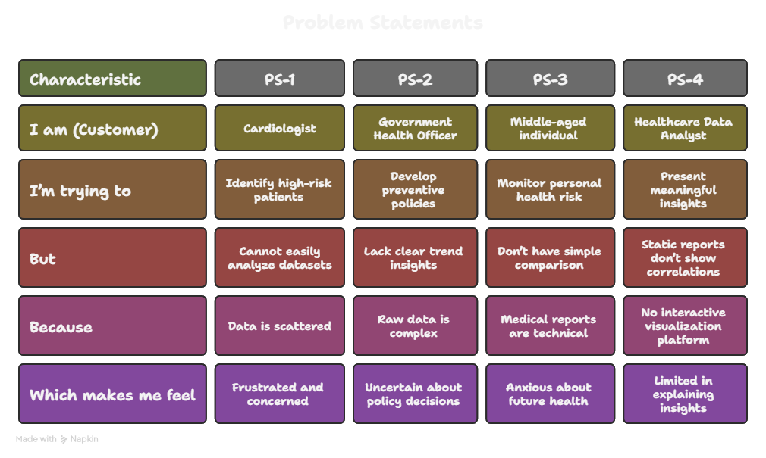
Reference: https://miro.com/templates/customer-problem-statement/
Example:
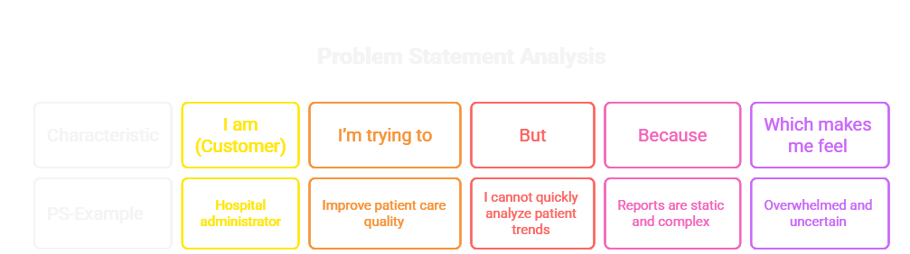

Problem Statement (PS) | I am (Customer) | I’m trying to | But | Because | Which makes me feel
PS-1 | A Cardiologist in a metropolitan hospital | Identify high-risk heart disease patients early | I cannot easily analyze large patient datasets with multiple risk factors | The data is scattered and not visually structured | Frustrated and concerned about missing critical warning signs
PS-2 | A Government Health Officer |  | I lack clear regional and lifestyle-based trend insights | The raw health data is complex and difficult to interpret | Uncertain about making effective policy decisions
  Officer
  Develop preventive health policies for heart disease

